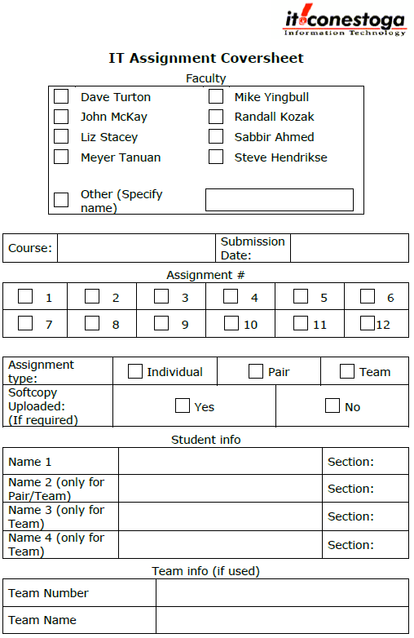

**√V**

**Heuijin Ko Sec3**

**√V**

**√V**

**√V**

Feb 20, 2020

Programming Mobile

Web Applications I

**Marking Sheet**

|  |  |  |  |  |
| --- | --- | --- | --- | --- |
|  | **Description** | **Marks Allocated** | **Marks Achieved** | |
| 1 | Home Page designed as specified | 5 |  | |
| 2 | Add a Feedback page is designed as specified | 10 |  | |
| 3 | Add a Feedback page ratings show/hide | 10 |  | |
| 4 | Add a Feedback page validation (in Save button’s click handler) | 15 |  | |
| 5 | Modify Feedback page is designed as specified | 5 |  | |
| 6 | Modify Feedback page ratings show/hide | 5 |  | |
| 7 | Modify Feedback page validation (in Update button’s click handler) | 15 |  | |
| 8 | Settings page stores info to local storage | 10 |  | |
| 9 | 7 screenshots | 13 |  | |
| 10 | Overall ratings is updated automatically whenever any of the quality, service, value changes in add and modify pages. | 6+6 |  | |
| **Deduction** | | | | |
|  | Assignment Standard (proper project name, this marking sheet, etc., see the standard documents for detail) | 5 x ________ |  | |
|  | Prefix missing for id and name attributes | 2 x ________ |  | |
|  | id attribute is missing for any input control | 3 x ________ |  |
|  | name attribute is missing for any input control | 3 x ________ |  |
|  | JavaScript file and function name not prefixed | 2 x ________ |  |
|  | Programming Standard | 1 x ________ |  |
|  | Bug | 3-10 based on severity |  |
|  | Late | ­­_________days |  |
|  | No Demo | 50 |  |
| **Total** | |  |  |